DEIB Report January 2023

DEIB Lead: Mary Alexander
Current DEIB Team Members: Donna Hallam, Andrew Walters, Susannah Cousins, Victoria Harrison, Jo O’Hare, Laura Bexson, Hannah Deacon, Hannah Adamson

Protected Characteristics
As a result of the 2010 Act, it is unlawful to discriminate against someone on the grounds of any of these characteristics: age, disability, gender reassignment, marriage or civil partnership, pregnancy and maternity, race, religion/belief, sex (gender) and sexual orientation. These are often referred to as protected characteristics.

Areas of Strength | Areas to Develop | What did we do next?
Large parts of the curriculum are built around issues that relate to under-represented groups. | To engage other stakeholders e.g. governors in developing engagement with issues regarding under-represented groups.  Working party from the community to share their authentic voices around certain issues. | Languages day  Introduced Bridge the Gap  Diversity Day
Curriculum is diverse, progressive and informative, Challenges and explores the protected characteristics. | Develop trips, speakers and visits that are as diverse as the curriculum.  Expose children to many variations of the same concept in order not to share a ‘single story’ | Increased RE trips  Languages day  Diverse books purchased – stories from other cultures.
Curriculum explores and celebrates difference. Pupils feel they can be seen within the curriculum and ethos. Own cultural identities welcome. | Expose children to many variations of the same concept in order not to share a ‘single story’ | Quality additional texts
Opportunities are provided for discussions around protected characteristics – often happen on set occasions throughout year e.g. Black History Month | Look at how individuals who are misrepresented are affected and impacted, for example looking at how media and other influences can produce biases.
Staff receiving CPD about DEI. Pupil voice leads much of the development in the school. | Create a clear approach to staff training around DEI that is revisited throughout the year.  Consider a staff library linked to DEI. | Pride Park inset.  Derby Opportunity Inclusion  Derby County Community Trust
School has created a ‘safe space’ ethos and environment for open, honest discussion where prejudicial views and stereotypes are tackled. | Develop conversations with more stakeholders, in particular, the governors. | DEIB Governor  Learning Ambassadors.
School’s processes and behaviour policy are starting to create a structure to deal with trauma.  Behaviour is dealt with through lens of inclusivity and cultural understanding. | To train all staff to deal with trauma-based incidents. | Update trauma and attachment training.
School welcomes local and wider communities but also ensures exposure to wider diverse global community. | Work strategically to look for links and opportunities for children to learn about wider context of school/world. Ways for children to not only learn about different cultures but from them.  Outside support from companies such as Lyfta to support learning from different world experiences. | Care in the community project  Community leader
How are we currently addressing DEIB at Lawn?

Global Citizenship curriculum.
Our Autumn 1 topics for all year groups specifically cover issues relating to DEIB, such as own identity, disability, gender stereotypes and diversity in sports.
Topics in other terms also provide children with opportunities to learn about issues relating to DEIB and the protected characteristics.
Below are the progression maps for the Global Citizenship curriculum that highlight the DEIB skills and knowledge our children gain during their time at Lawn:
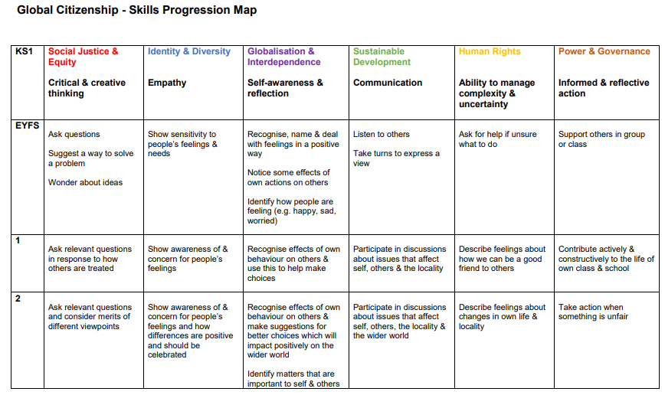

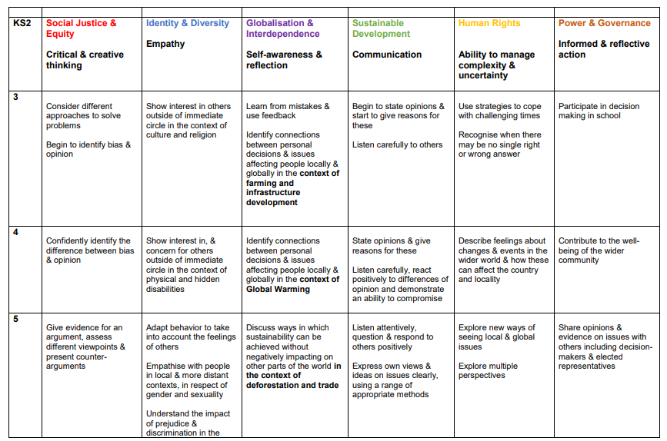
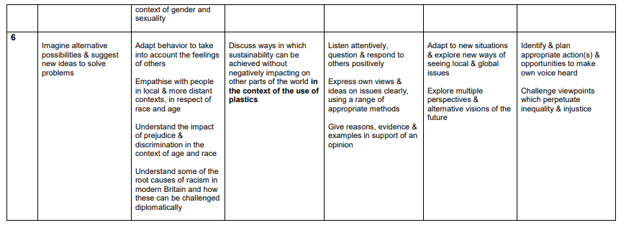
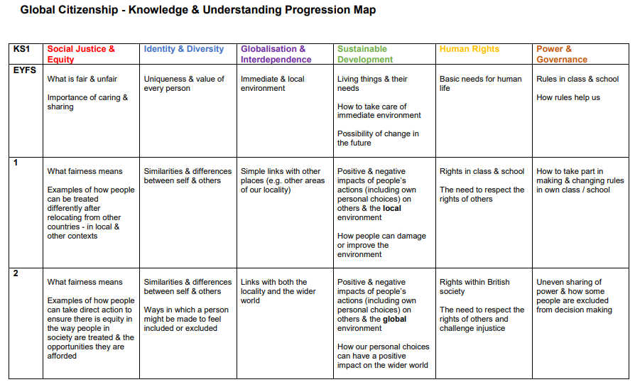
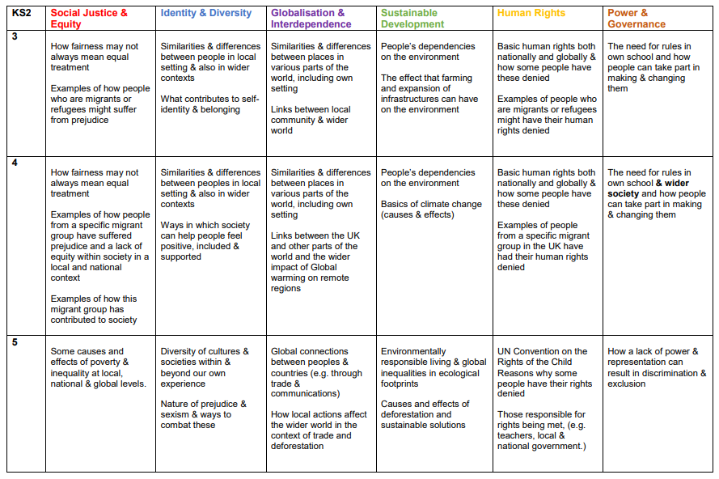
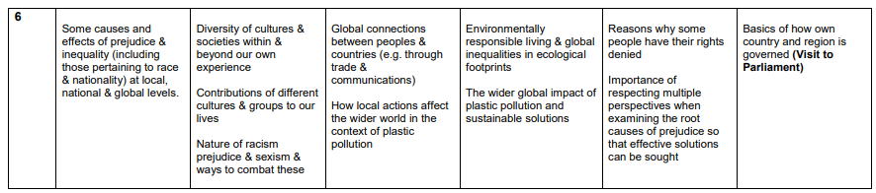

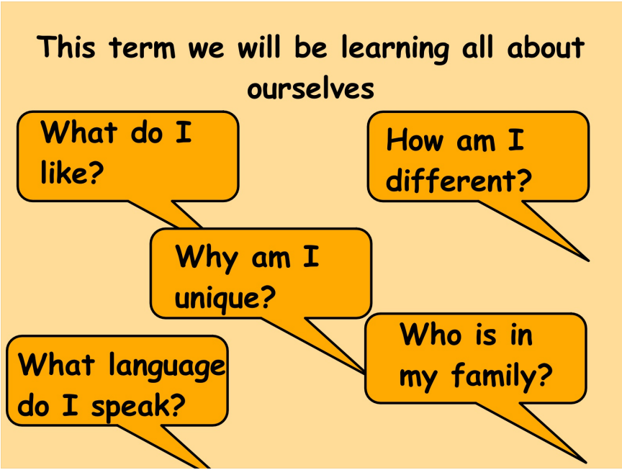 Year 1 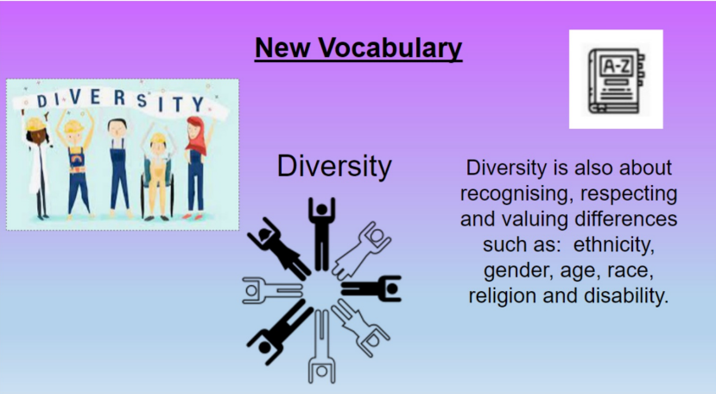 Year 2 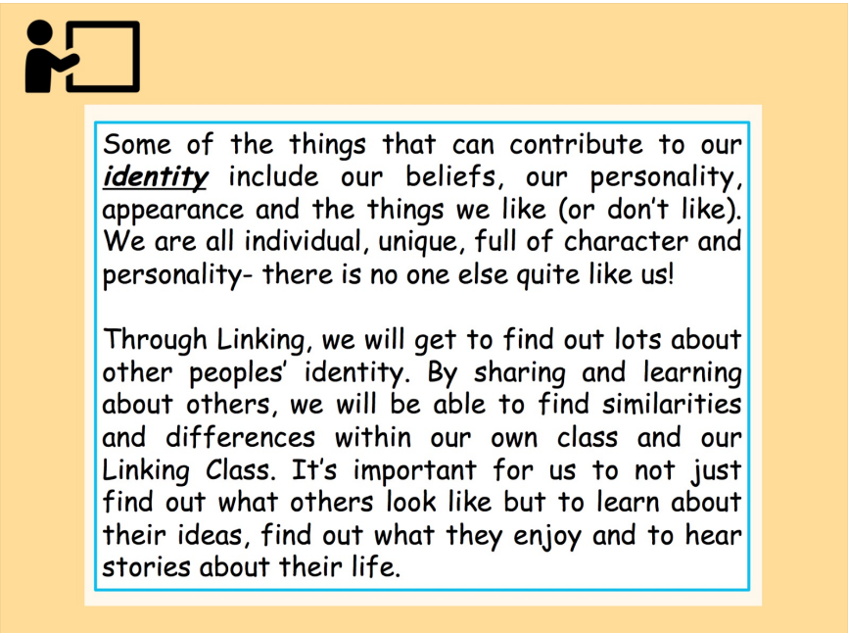 Year 3 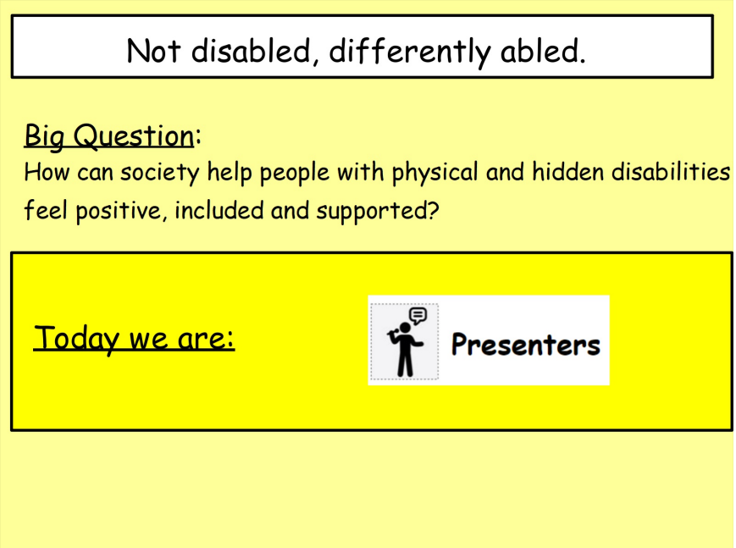 Year 4
 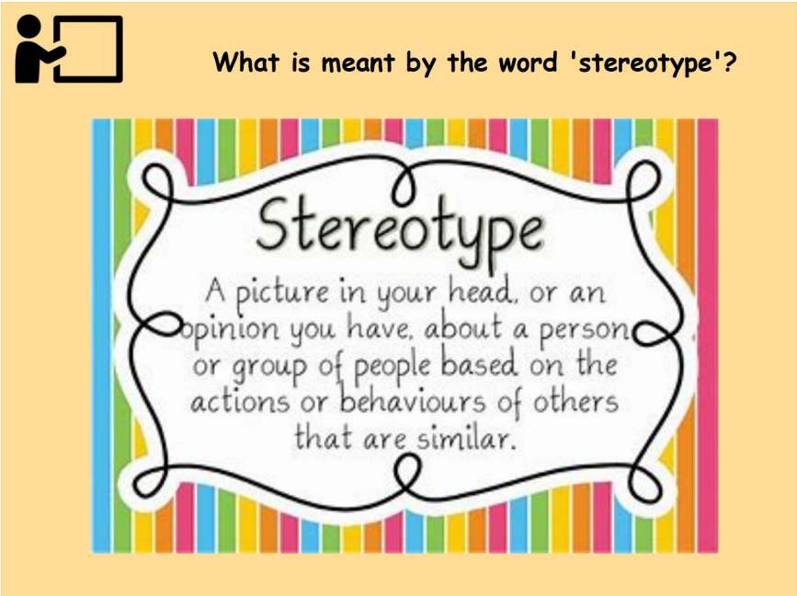 Year 5
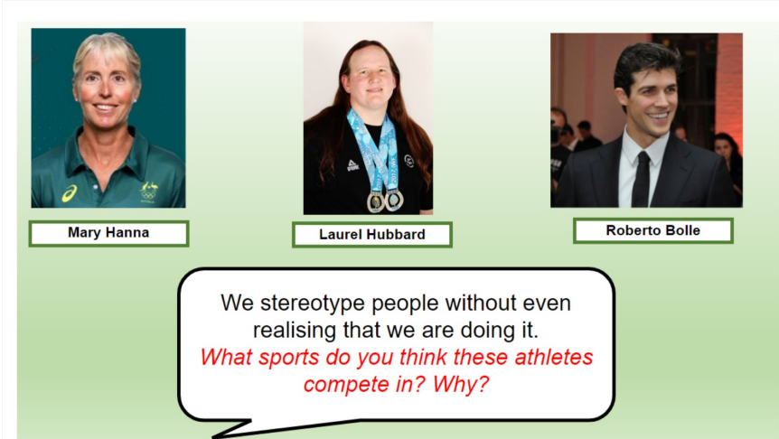 Year 6

No Outsiders
At the start of each half term, every class in the school takes part in a ‘No Outsiders’ lesson. No Outsiders enables children to recognise and embrace the diversity around them in preparation for global citizenship. The ethos teaches that ‘there are no outsiders here because everyone is welcome’. The resource uses the Equality Act 2010 as a foundation to ensure no protected characteristic is left out. 42 picture books are used in the scheme with lesson plans from EYFS- Y6 to ensure consistency and progression.
FS2 | Text | Learning Intention
Autumn 1 | You Choose by Nick Sharratt & Pippa Goodheart | I can choose what I like
Autumn 2 | Red Rockets and Rainbow Jelly by Sue Heap & Nick Sharratt | It’s ok to like different things
Spring 1 | Hello, Hello by Brendan Wenzel | To say hello
Spring 2 | The Family Book by Todd Parr | All families are different
Summer 1 | Mommy, Mama and Me by Leslea Newman & Carol Thompson | To celebrate my family
Summer 2 | Blue Chameleon by Emily Gravett | To make a new friend
The aim in FS2 is to introduce the No Outsiders ethos using simplistic language; we are all different and we are all friends. The key message that it’s ok to be you and you may be different to me but that’s ok too.

Year 1 develops the understanding of difference to consider ways in which we might be different and how that can sometimes make you feel.
Y1 | Text | Learning Intention
Autumn 1 | Elmer by David Mckee | I like the way I am
Autumn 2 | Going to the Volcano by Andy Stanton | To join in
Spring 1 | Want to Play Trucks? By Ann Stott and Bob Graham | To find ways to play together
Spring 2 | Hair, It’s a family Affair by Mylo Freeman | Proud to be me
Summer 1 | My World Your World by Melanie Walsh | I share the world with lots of people
Summer 2 | Errol’s Garden by Gillian Hibbs | To work together

Year 2 introduces the word diversity and explores its meaning.
Y2 | Text | Learning Intention
Autumn 1 | Can I Join Your Club? By John Kelly and Steph Laberis | To welcome different people
Autumn 2 | How to Be a Lion by Ed Vere | To have self-confidence
Spring 1 | The Great Big Book of Families by Mary Hoffman & Ross Asquith | To understand what diversity is
Spring 2 | Amazing by Steve Antony | To think about what makes a good friend
Summer 1 | What the Jackdaw Saw by Julia Donaldson and Nick Sharratt | To communicate in different ways
Summer 2 | All Are Welcome by Alexandra Penfold and Suzanne Kaufman | To know I belong

Year 3 focuses on bystanders and stereotypes. Mental Health is also referred to.
Y3 | Text | Learning Intention
Autumn 1 | This is Our House by Michael Rosen | To understand what discrimination means
Autumn 2 | We’re all Wonders by R.J Palacio | To understand what a bystander is
Spring 1 | Beegu by Alexis Deacon | To be welcoming
Spring 2 | The Truth About Old People by Elina Ellis | To recognise a stereotype
Summer 1 | The Hueys in the New Jumper by Olivers Jeffers | To recognise and help and outsider
Summer 2 | Planet Omar: Accidental Trouble Magnet by Zanib Mian | To consider living in Britain today

Year 4 focuses on attitudes towards racism and identity and also touches on mental health.
Y4 | Text | Learning Intention
Autumn 1 | Along Came a Different by Tom McLaughlin | To help someone accept difference
Autumn 2 | Dogs Don’t Do Ballet by Anna Kemp & Sarah Oglivie | To choose when to be assertive
Spring 1 | Red: A Crayon’s story by Michael Hall | To be proud of who I am
Spring 2 | Aalfred and Aalbert by Morag Hood | To find common ground
Summer 1 | When Sadness Comes to Call by Eva Eland | To look after my mental health
Summer 2 | Julian Is a Mermaid by Jessica Love | To show acceptance

Year 5 looks at attitudes towards LGBT+ people and homophobia. Mental health is referenced.
Y5 | Text | Learning Intention
Autumn 1 | Kenny Lives with Erica and Martina by Olly Pike | To consider consequences
Autumn 2 | Rose Blanche by Ian McEwan & Roberto Innocenti | To justify my actions
Spring 1 | Mixed by Arree Chung | To consider responses to racist behaviour
Spring 2 | How to Heal a Broken Wing by Bob Graham | To recognise when someone needs help
Summer 1 | The Girls by Lauren Lee & Jenny Lovelie | To explore friendship
Summer 2 | And Tango Makes Three by Justn Richardson & Peter Parnell | To exchange dialogue and express opinion

Year 6 have a theme of acceptance, consequences of actions and democracy.
Y6 | Text | Learning Intention
Autumn 1 | King of the Sky by Nicola Davies | To consider responses to immigration
Autumn 2 | The Only Way to Badger by Stella J. Jones & Carmen Saldena | To consider language and freedom of speech
Spring 1 | Leaf by Sandra Dieckmann | To overcome fears about difference
Spring 2 | The Island by Armin Greder | To consider the causes of racism
Summer 1 | Introducing Teddy by Jessica Walton and Dougal Macpherson | To show acceptance
Summer 2 | A Day in the Life of Marlon Bundo by Marlon Bundo and Jill Twiss | To consider democracy

Rights Respecting Schools Award
Through references made in lessons, assemblies, School Parliament/Class Council meetings, Class Charters, the children learn about the United Nations Convention on the Rights of the Child (UNCRC). They understand that all children have the same rights and that these rights impact their lives such as the right to be treated equally or have their own voice and identity.
There are 3 strands to becoming a Rights Respecting School:
- Strand A – teaching and learning about rights
- Strand B – teaching and learning through rights (ethos and relationships)
- Strand C – teaching and learning for rights (participation, empowerment and action)

Resources
We are constantly adding to our range of reading materials to ensure that different ‘voices’ are represented and accessible at school. The deliveries from the Education Library Service mean that we can provide the children with a wealth of information on a range of topics. The recent introduction of iPads for all children in the school also means that learning can be resourced, accessed and recorded in increasingly inclusive ways.

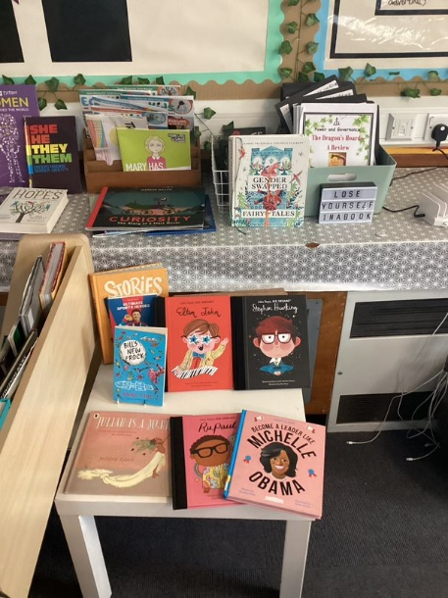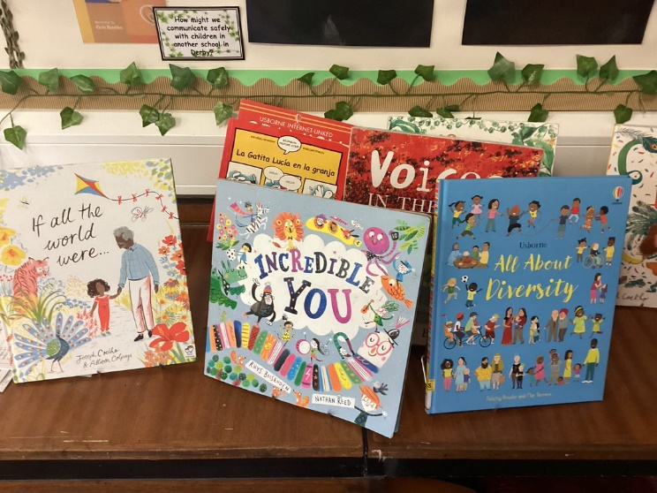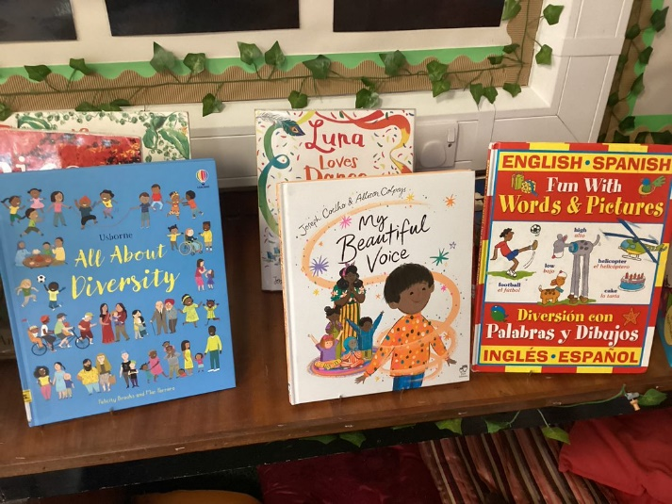
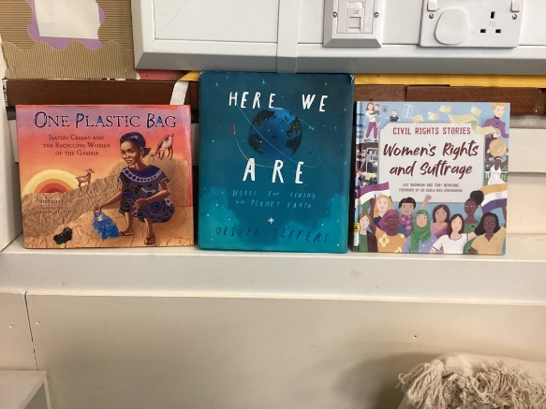

Wider Opportunities
Children at Lawn are able to participate in a range of trips and visits which enrich their understanding of the world. Examples of such trips include visits to churches, mosques and gurdwaras. As part of Transform Trust, we also participate in collective worship assemblies with other members of the Trust, such as the Harvest assembly hosted by Zaytouna Primary School. We learnt about how shared concepts can be celebrated differently yet still with similar significance. Another way in which our children learn about different viewpoints is the longstanding and ongoing global citizenship initiative with Akaal Primary. Each year, Y3 pupils in both schools share work and ideas and get to know each other through a series of meetings, at Pride Park stadium and at both schools. It is an ideal, real-life opportunity to learn about similarities and differences. and over time has become embedded into our curriculum.
On Monday 26th September 2022, the school held a Languages Day in which different languages were celebrated and parents were invited in to teach the children a language spoken at home by children at Lawn, for example, Y5MA were taught some German.

CPD
Teachers, teaching assistants and representatives from across the school attended an Inset day at Pride Park on the 7th October 2022. The theme of the Inset was diversity.

Future Plans for DEIB at Lawn

Diversity Day
Prompted by a discussion at School Parliament there will be a ‘Diversity Day’ on Friday 10th February (this date was chosen to avoid clashes with other school events throughout the year). Miss Alexander will attend the School Parliament meeting on Monday 16th January to help decide on what will happen on this day.

Girls Football
Again prompted by a discussion at School Parliament, the issue of how to get more girls involved in playing football was raised. Discussions between School Parliament and the PE Lead have resulted in exploring ways to support this.

Audit of involvement in afterschool clubs
DEIB Lead to obtain lists of children who have been/are involved in school clubs to check for inclusion of PP/EAL/SEND.

Staff/parent/pupil voice
DEIB Lead to gather staff/parent/pupil voice relating to DEIB and the protected characteristics.

Examples of the sort of questions/learning



